Part 1 Results
Plot:

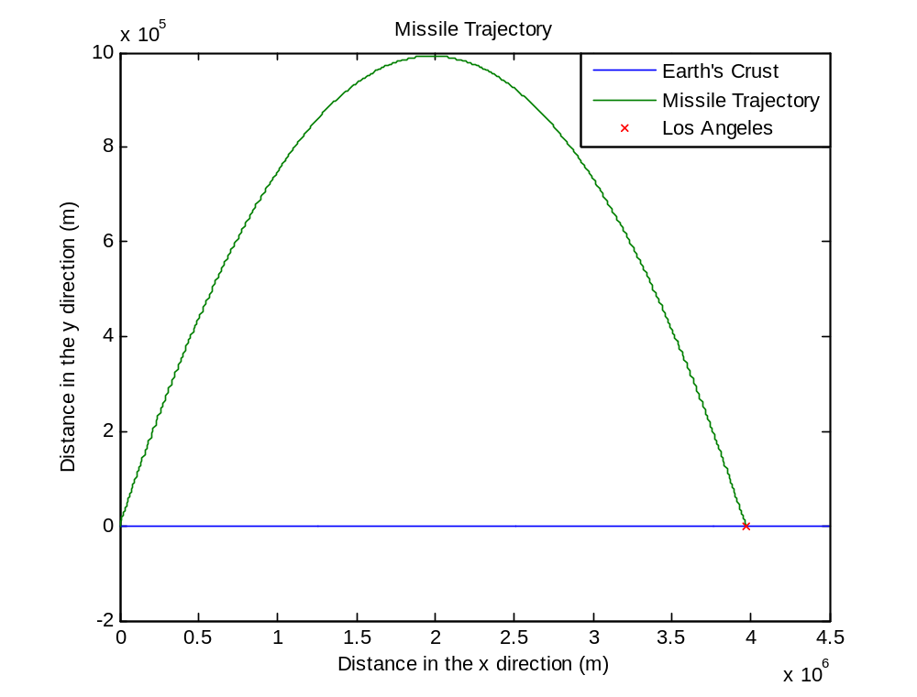

X distance error: 77.01m (Carlos change this to a percent)
Y distance error: 15.76m (Carlos change this to a percent)

Optimum Initial Velocity: 6241.9 seconds
Optimum Initial Angle: 45 degrees (θ in Figure ______ )

Time of Flight: 899.84 seconds

Runge-Kutta Step Size: 0.02

Angle Step Size: 1 Degree for Optimization

Max Allowable x Distance Error: 100m

Part 2 Results
Plot:
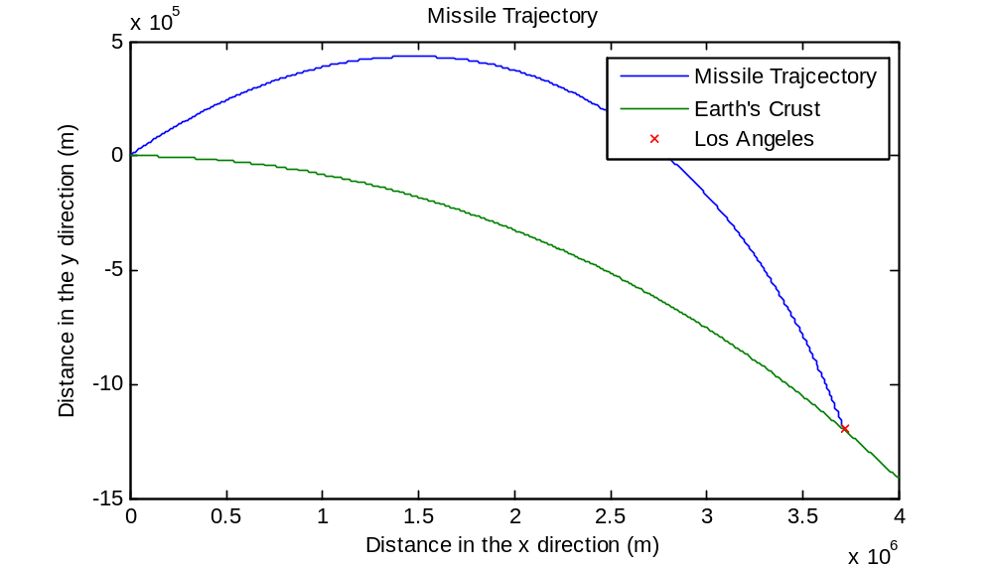
X distance error: 43.4m (Carlos change this to a percent)
Y distance error: 67.3 (Carlos change this to a percent)

Optimum Velocity: 5840.4m/s
Optimum Angle: 30 degrees (θ in Figure ______ )

Runge-Kutta Step Size: 0.02

Angle Step Size: 1 degree for optimization

Max allowable x distance error: 100m

Time of Flight: 896.28 Seconds

Part 3 Results
Plot:
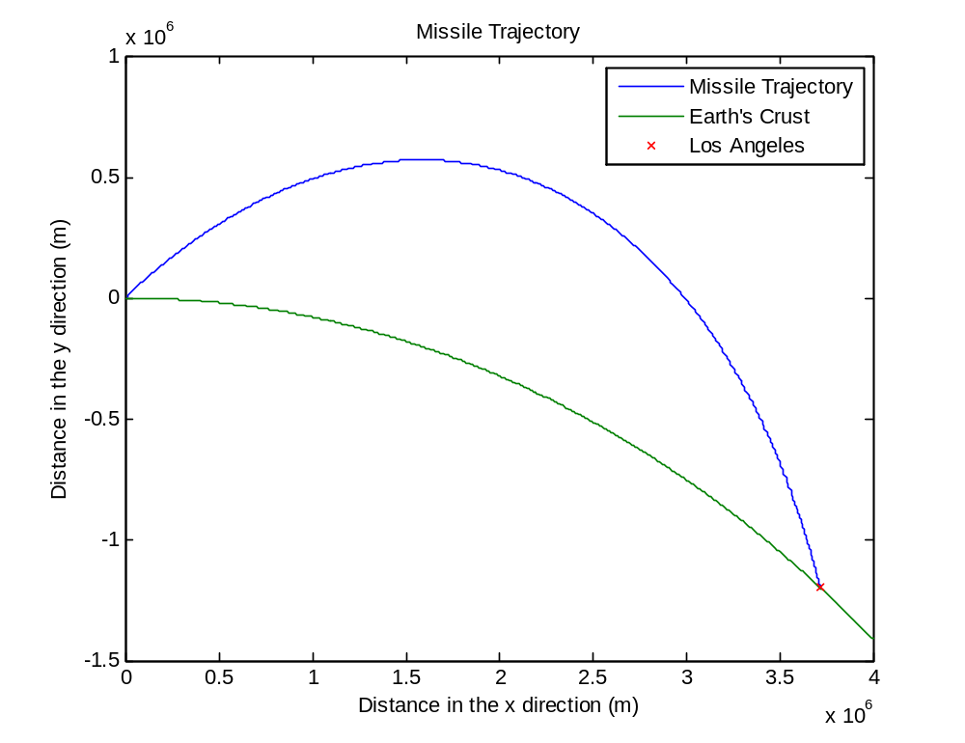

X distance error: 34.6m (Carlos change this to a percent)
Y distance error: 70.2m (Carlos change this to a percent)

Optimum Velocity: 5414.5m/s
Optimum Angle: 36 degrees (θ in Figure ______ )

Runge-Kutta Step Size: 0.02

Angle Step Size: 1 degree for optimization

Max allowable x distance error: 100m

Time of Flight: 1065.9 seconds

Part 4 Results
Plot:
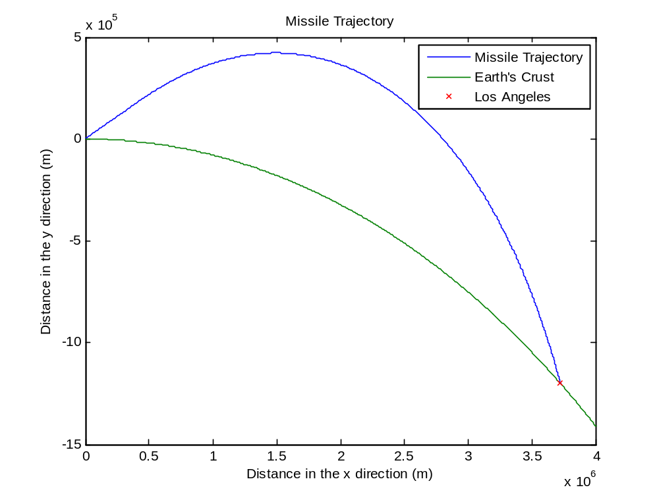

X distance error: 160.23m
Y distance error: 112.21m

Thrust: 33.3m/s²
Optimum Thrust Time: 180.11 seconds
Optimum Initial Angle: 39 degrees

Time of Flight: 1068.1s

Runge-Kutta Step Size: 0.02

Angle Step Size: 1 Degree for Optimization

Max Allowable x Distance Error: 1000m

MISSILE COMPARISONS: Missile 1 & 2 in World 2

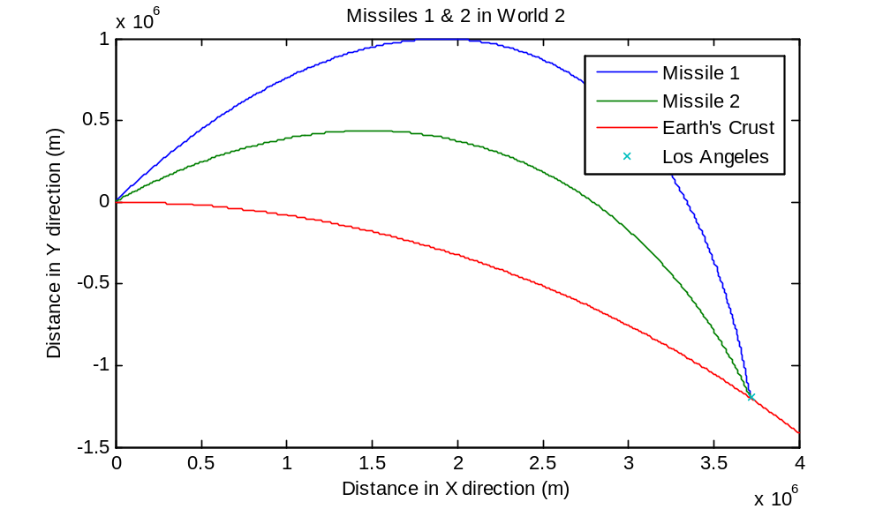

Missile 1
Error (x): -1.4452e+003
Error (y): 1.0348e+003

Missile 2
Error (x): 32.6277
Error (y): -74.9739

Missiles 1,2,3 in World 3

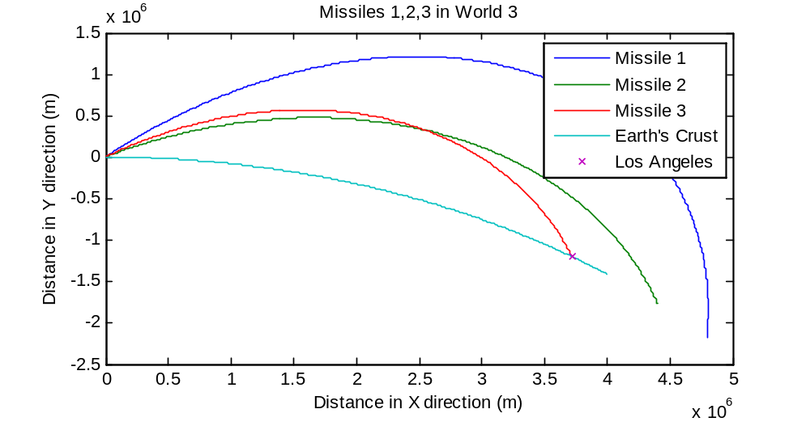

Missile 1
Error (x): 1.0730e+006
Error(y): -9.7291e+005

Missile 2
Error(x): 6.7877e+005
Error(y): -5.6234e+005

Missile 3:
Error(x): -24.1294
Error(y): 3.3227

